**CS:4400 Query Description**

**Team #5**

1. Given From, To, Depart, Return, and # of passengers find a round trip

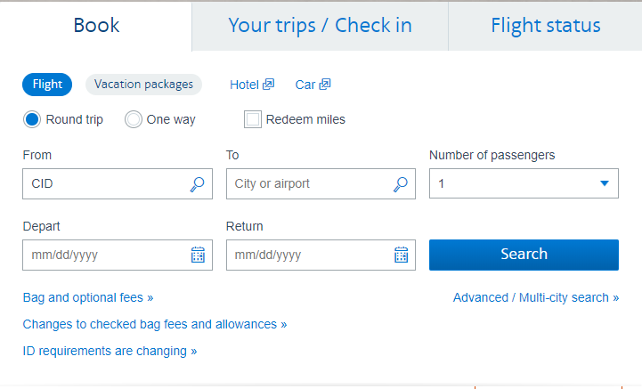

1. Given From, To, Depart, and # of passengers find a one way trip

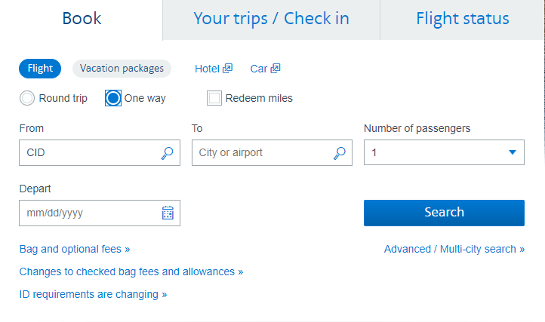

1. Given multiple From, To, Depart, Time of Day, and # of passengers find a multi city trip

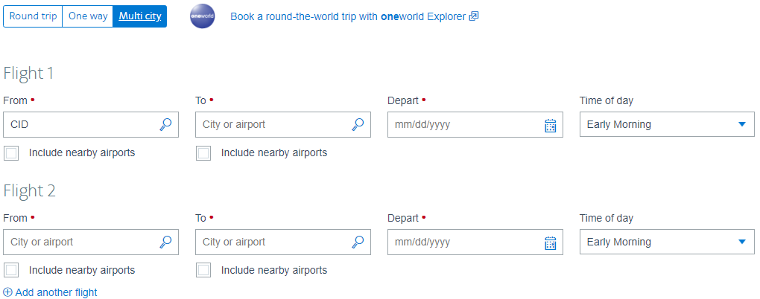

1. Given the trip, get the fare, baggage, and classes options

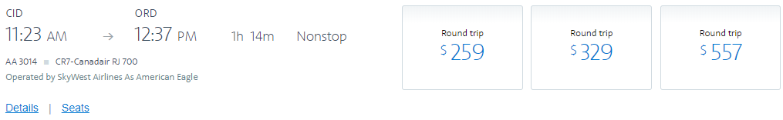

1. Get the number of available seats for a flight and get ticket number for passenger after booking

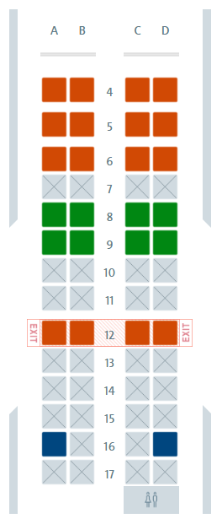

1. Given first name, last name, and record locator, find person’s trip (no login required)

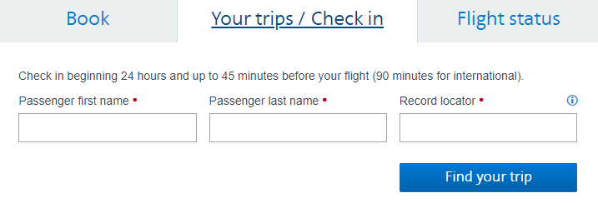

1. Given From, To, Date, find all flights on that day ordered by time

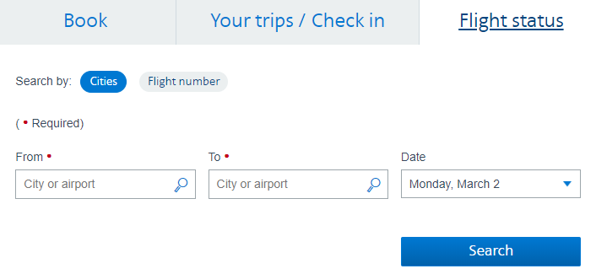

1. Given flight number and Date, find the flight

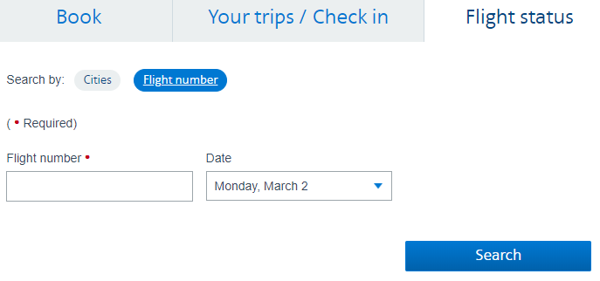

1. Given a flight, check how many hours until that flight, if already happened, or if there is a delay

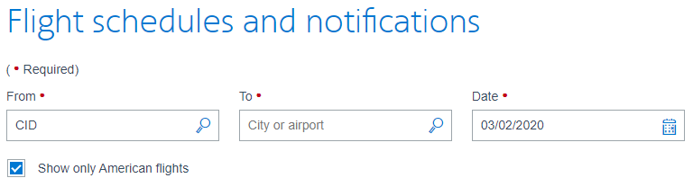

1. Given #AAdvantage or username, last name, password, validate the user

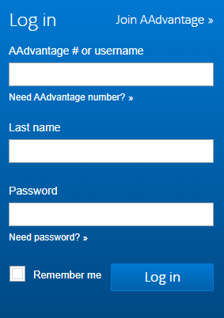

1. Given username and password, validate admin account

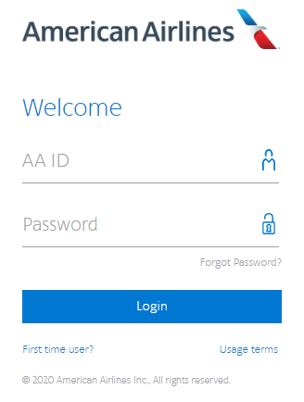

1. Given Fromm, To, and Date, find all connecting flights with a reasonable gap in between them

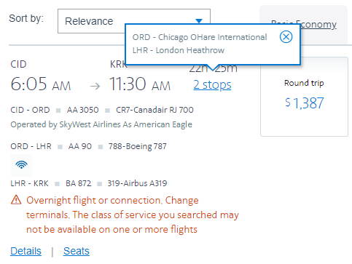

1. Given a user, extract their information to display, such as upcoming flights, my trips, etc.

We can’t take a screenshot of this because we don’t have any plane tickets

1. Given a user cancelling their flights add those seats back to their flights and remove a booking

Happens on the back-end

1. When changing a flight, get similar connection available (same day, next day max)

We can’t take a screenshot of this because we don’t have any plane tickets

1. CRUD - Get all aircrafts and display their information to on admin panel
2. CRUD - Get all flights that exists in the database to display on admin panel
3. CRUD - Get all airports that exists in the database to display on admin panel
4. CRUD - Get a list of passengers for a specific flight on admin panel
5. CRUD - Get a list of all flights for a specific day on admin panel
6. CRUD - Get all information about a passenger on admin panel
7. CRUD - Get all bookings on admin panel

All these will be happening on the admin panel. Only the airport staff will have access to these queries. Not possible to take screenshots of these screens since we aren’t AA employees.

1. Get the latest news, pictures, headlines, and text to display on the main page

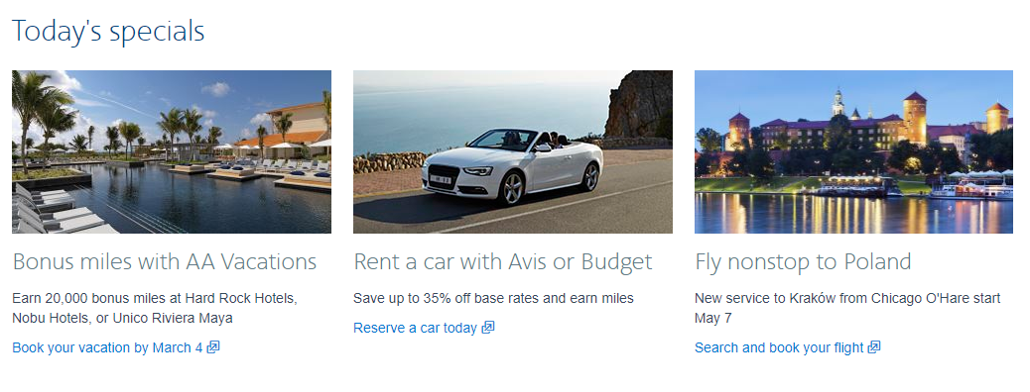

1. Get the contact information and email address to display on the main page

